

Activity 1.3.1 Solar Hydrogen System

Purpose
Hydrogen is the most plentiful element in the universe. It can be burned in oxygen to produce heat or combined with oxygen in a fuel cell to produce heat and electricity. Hydrogen on Earth is found bonded with other elements; for example, bonded hydrogen and oxygen comprise water. Hydrogen can be stored once it has been separated from other elements. Hydrogen can be captured in several different ways. The most economical way to harness hydrogen is through existing fossil fuels. Engineers and scientists are working to find ways to decrease the cost of harnessing hydrogen from other sources like water and some forms of algae. | 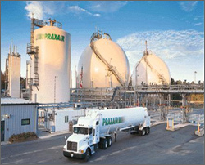  Hydrogen storage and transportation  U.S. Department of Energy
Equipment

- Hydrogen fuel cell
- Solar module
- Solar hydrogen car
- Tape measure
- Wires
- Distilled water
- Multimeter
- Stopwatch or other timing device
- 5 ohm or 10 ohm resistor

(Important – When measuring “no load” fuel cell current, place a 5 ohm or 10 ohm resistor in the measurement circuit. If the resistor is not added to the circuit and the multimeter is connected directly to the fuel cell for current measurement, a short circuit may result, creating a potentially dangerous situation.)

Procedure
In this activity your team will use a solar module to produce electricity. You will use the electricity from the solar module to separate hydrogen from oxygen, harness the hydrogen, and then use the hydrogen as fuel. Although teams will complete this activity, each student should individually complete this entire document.

This activity was written to be used with the Heliocentris fuel cell. Whether you are using this equipment or other equipment, refer to the manufacturer’s instructions to be sure that you are using the equipment as designed.

- Position the fuel cell module with the hydrogen and oxygen storage cylinder caps facing up.  Note: The numbers on the cylinder scale should be upside down, and the negative terminal should be on top. | 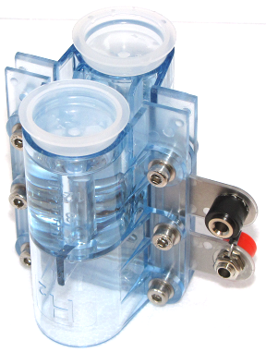
- Remove the fuel cell storage cylinder caps. Fill the storage cylinders with distilled water until the water reaches the top of the fixed tubes inside the cylinder. | 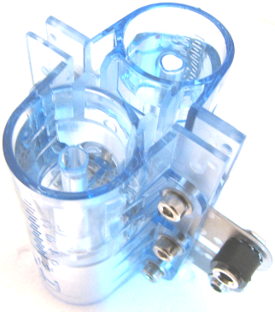
- Fasten the storage cylinder caps by pushing down firmly. Turn the fuel cell module over so that the cylinder caps are facing down.  Note: The fuel cell module works better after it has been wet for some time. | 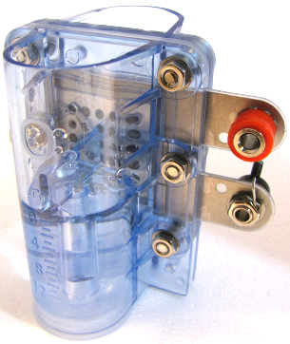
- Set your multimeter to measure voltage. Connect multimeter test leads to the solar module terminals. Move the module or light source to determine the location that produces the highest voltage value. Record the no load voltage value.  No Load Voltage __________ | 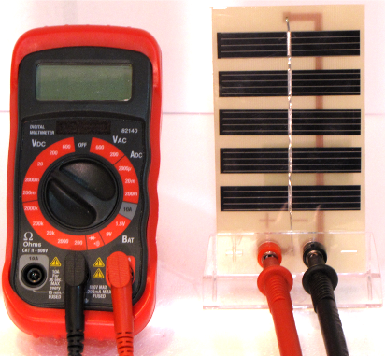
- Set your multimeter to measure current. Return the solar module to the position that produced the highest voltage value and measure the systems current. Record the no load current value.
No Load Current __________

- Calculate the wattage produced by the solar module (Wattage = Voltage x Current) Wattage = ________

- Attach the solar module to the solar hydrogen automobile. Position the automobile drive motor so that its gear is not in contact with the red drive gear. Connect the automobile motor leads to the solar module. Position the light source to produce maximum voltage. Is there enough power to turn the motor?
__________
- Engage the drive gear by letting the motor gear rest on top of the drive gear. Can the solar module power the car on the ground? __________
- Set your multimeter to measure voltage. Connect multimeter test leads to the solar module terminals. Record the load voltage value.(Drive gear should be engaged) Load Voltage __________ | Internal Resistance Equation
- Set your multimeter to measure current. Connect multimeter test leads to the solar module terminals. Record the load current value.(Drive gear should be engaged) Load Current __________

- Calculate the internal resistance of the solar module and motor circuit. ________________
- Charge the fuel cell by connecting the solar module and fuel cell module positive and negative terminals.  Note: You should begin to see bubbles form as the hydrogen container fills. You may wish to complete some of the conclusion questions while the fuel cell is charging. | 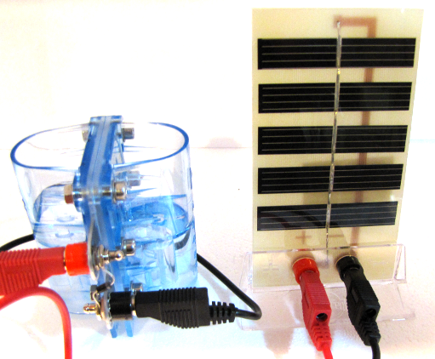
- When all of the water has completely transferred from the lower cylinder storage container to the upper cylinder storage container, the fuel cell is fully charged. Set the multimeter to read voltage. Connect the multimeter test leads to the fully charged fuel cell terminals. Record the voltage value.
Voltage __________
- Set the multimeter to measure current. Attach a 5-10 Ohm resistor (like a Fischertechnik light bulb) to the positive terminal of the fuel cell. Connect the multimeter test leads to the fully charged fuel cell module negative terminal and chosen resistor. Record the current value. Current __________
- Calculate the wattage produced by the fuel cell module
(Wattage = Voltage x Current). Wattage = __________

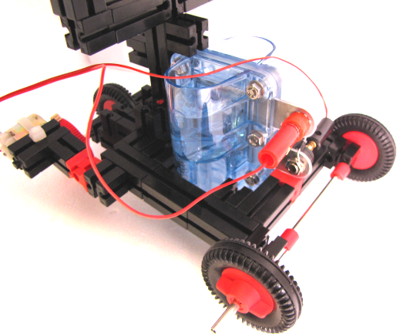
- Attach the fuel cell module to the solar hydrogen car. Position the drive motor so that its gear is not in contact with the red drive gear. Connect the automobile motor leads to the fuel cell module. Is there enough power to turn the motor? _____________
- Engage the drive gear by letting the motor gear rest on top of the drive gear. Can the fuel cell power the car on the ground? ___________
- If the automobile will travel, record how long it takes for the car to travel 5.0 ft. _________
- Calculate the speed in ft/s. ______________
- Set your multimeter to measure voltage. Connect multimeter test leads to the fuel cell terminals. Record the load voltage value. (Drive gear should be engaged)
Load Voltage __________
- Set your multimeter to measure current. Connect multimeter test leads to the solar module terminals. Record the load current value.
Load Current __________
- Calculate the internal resistance of the fuel cell and motor circuit. ________________
- Which of the two systems had a higher wattage value? ____________

Conclusion:
- Based on your observations, what are the advantages and disadvantages of a car utilizing solar power?

- Which one would most likely have the higher travel speed.

- Based on your observations, what are the advantages and disadvantages of a car utilizing hydrogen fuel cell power?

- Describe and defend a system that you believe would best utilize a solar hydrogen system to meet the needs for an average driver.

- How does a photovoltaic cell work? Record the source of your information.

- Detail how electrolysis separates hydrogen and oxygen. How is electricity produced by the bonding of hydrogen and oxygen? Record the source of your information.

