Apprenticeships
An apprenticeship is a program that trains you to become skilled in one particular trade or profession, whether it be hairstyling, plumbing, electrical work, etc. It typically combines classroom learning with hands-on work.
MCIS - How to find and Prepare for an Apprenticeship  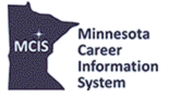 | This interview explores how a student can use the MCIS website to learn about apprenticeships, find an apprenticeship by region or career, and how to prepare for one.
Twin Cities Area Apprenticeship Training Centers | An apprenticeship in the construction and building trades features modern, state-of-the-art training facilities; knowledgeable and experienced trainers; and a challenging and rewarding course of study.  ​The application process and requirements differ from trade to trade, so be sure to spend time at the training center webpage that interests you.
Laborers Training Center  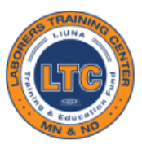 | The Laborers Training Center (LTC) provides industry-specific vocational skills and certification renewal training for its members in Minnesota and North Dakota.
Women Building Success   | If you have ever wondered what it would be like to work in the construction industry, please listen to this panel, coordinated by Hennepin Technical College, of seasoned tradeswomen who have navigated various apprenticeships and achieved leadership positions within the trades.
ICATT Apprenticeship Program Overview   | The ICATT Apprenticeship Program is a global program that combines company-specific knowledge and hands-on learning to train a competitive workforce.
Manufacturing Apprenticeship   | Joseph T. Ryerson has locations in Coon Rapids and Plymouth and recently developed an 18-month apprenticeship program to help train future employees while giving them the opportunity to earn credentials and become fully employed.
Pipefitters Apprenticeship  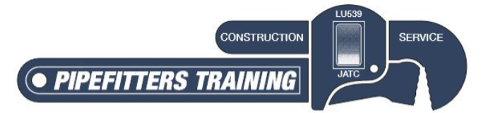 | A pipefitter apprenticeship is a five-year paid program in which apprentices receive both on-the-job practical training and classroom instruction. Apprentices attend school in the evening, typically two nights a week. They must pass all courses with a minimum score of 70% to advance to the next year in the program. Tuition for school is $540.00 per year plus books. Apprentices will graduate to journey-level workers after passing the Minnesota State Pipefitting License exam.

