Macromolecules Worksheet
Explain the versatility of carbon in molecule formation by its electron configuration and the kinds and numbers of bonds carbon will form.

Which of the following compounds would contain a double bond?
  - C₃H₈ b. C₂H₆ c. CH₄ d. C₂H₄ e. C₂H₂

IDENTIFYING FUNCTIONAL GROUPS: Circle the functional group(s) and write the functional group name(s) on the first line. Then write the chemical formula on the second line.
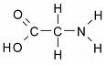
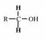
1. 2.

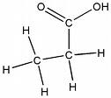
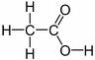

3. 4.
BUILDING A MACROMOLECULE:
Explain the relationship between monomers and polymers and explain how these molecules are related to the “unity and diversity of life.”

Explain how monomers are linked together and how they are disassembled (include an illustration of each process)

Use the diagram below and then answer the following questions.
+
+
+

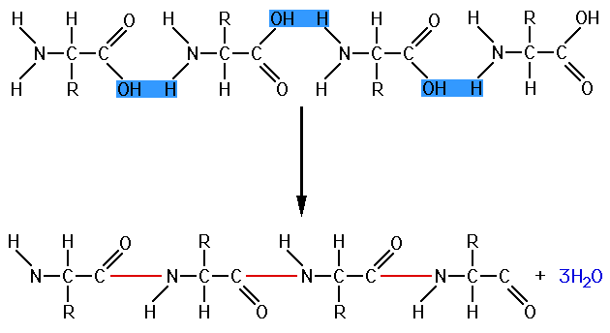

- What are the reactants? ____________________________________
- What are the products? _____________________________________
- Is the reaction a condensation reaction or hydrolysis?
- Circle the peptide bonds. How many peptide bonds are present?_____
- How many molecules of water are produced in order to form the peptide bonds?__________
- If a protein contained 200 peptide bonds, how many molecules of water do you suppose would be required to break it down into its components? ___________
- What is the ratio of molecules of water to the number of peptide bonds? __________
Macromolecule properties
Complete the following chart
Class | Monomer | Functions
 | Monosaccharide
 |  | Energy storage, membranes and steroids
Proteins

 | Nucleotides
ts 5.2-5.4

The following questions are based on the 15 molecules illustrated below. Each molecule may be used once, more than once, or not at all.

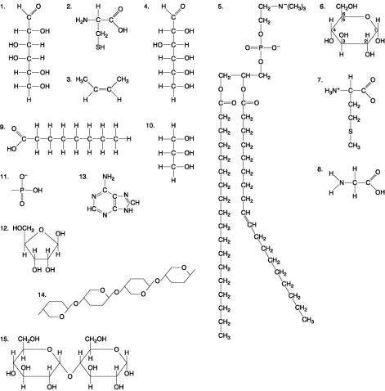

1) Which of the following molecules are structural isomers?
A) 1 and 4 B) 5 and 14 C) 6 and 12
D) 12 and 13 E) 14 and 15
Answer: A Skill: Compr
2) Which of the following combinations could be linked together to form a nucleotide?
A) 1, 2, and 11 B) 3, 7, and 8 C) 5, 9, and 10
D) 11, 12, and 13 E) 12, 14, and 15
Answer: D
3) Which of the following molecules contain(s) an aldehyde type of carbonyl functional group?
A) 1 B) 4 C) 8 D) 10 E) 1 and 4 er: E

4) Which of the following molecules is (are) a carbohydrate?
A) 1 and 4 B) 6 C) 12
D) 5 and 14 E) all of the above
Ans
5) Which of the following molecules is a saturated fatty acid?
A) 1 B) 5 C) 6 D) 8 E) 9
Answ
6) Which of the following molecules is a purine type of nitrogenous base?
A) 2 B) 3 C) 5 D) 12 E) 13
Answer: E Topic: Concept 5.5
7) Which of the following molecules act as building blocks (monomers) of polypeptides?
A) 1, 4, and 6 B) 2, 7, and 8 C) 7, 8, and 13 D) 11, 12, and 13 E) 12, 13, and 15
Answer:
8) Which of the following molecules is an amino acid with a hydrophobic R group or side chain?
A) 3 B) 5 C) 7 D) 8 E) 12
Answer: C
9) Which of the following molecules could be joined together by a peptide bond as a result of a dehydration reaction?
A) 2 and 3 B) 3 and 7 C) 7 and 8 D) 8 and 9 E) 12 and 13
Answer: C
10) A fat (or triacylglycerol) would be formed as a result of a dehydration reaction between
A) one molecule of 9 and three molecules of 10.
B) three molecules of 9 and one molecule of 10.
C) one molecule of 5 and three molecules of 9.
D) three molecules of 5 and one molecule of 9.
E) one molecule of 5 and three molecules of 10.
Answer: B
11) Which of the following molecules could be joined together by a phosphodiester type of covalent bond?
A) 3 and 4 B) 3 and 8 C) 6 and 15
D) 11 and 12 E) 11 and 13
Answer: D Comprehension
12) Which of the following molecules is the pentose sugar found in RNA?
A) 1 B) 4 C) 6 D) 12 E) 13
Answer: D
13) Which of the following molecules contains a glycosidic linkage type of covalent bond?
A) 4 B) 6 C) 12 D) 13 E) 15
Answ

14) Which of the following molecules has (have) a functional group that frequently is involved in maintaining the tertiary structure of a protein?
A) 2 B) 3 C) 9 D) 11 E) 9 and 11
Answer: A
15) Which of the following molecules consists of a hydrophilic "head" region and a hydrophobic "tail" region?
A) 2 B) 5 C) 7 D) 9 E) 11
Answer: B
16) Which of the following statements is false?
A) 1 and 4 could be joined together by a glycosidic linkage to form a disaccharide.
B) 9 and 10 could be joined together by ester bonds to form a triacylglycerol.
C) 2 and 7 could be joined together to form a short peptide.
D) 2, 7, and 8 could be joined together to form a short peptide.
E) 14 and 15 could be joined together to form a polypeptide.
Answer: E
Proteins
Draw and explain the structure of an amino acid. Explain how it is possible for proteins to vary extensively when there are only 20 naturally occurring amino acids and what determines this variety.

What is a peptide? What is a polypeptide?

Explain the functions of proteins in the cell and include an example of each type.
- Structural
- Storage
- Transport
- Defensive
- Enzymes
- Movement
- Receptors

Describe the different levels of protein structure in detail.

Explain denaturation and list things that can cause it.

Lipids
Draw the structure of a typical fat consisting of three fatty acids and one glycerol molecule. This molecule is called a triglyceride.

Explain why the structure of phospholipids are ideal for the structure and function of the cell membrane.

Explain why people tend to store more fat with age.

Define a saturated fatty acid. Provide one example of a saturated fatty acid.

Define an unsaturated fatty acid. Provide one example of an unsaturated fatty acid.

Define a polyunsaturated fatty acid.

Draw, label, and describe the structure of a phospholipid. Include the head region, the tail region, hydrophobic region, and hydrophilic regions

Draw the structure of a typical steroid.

Describe the function of steroids.

Each of the following structural formulas shows a fatty acid molecule. On the line, identify the fatty acid as saturated, unsaturated, or polyunsaturated.

1.______________________
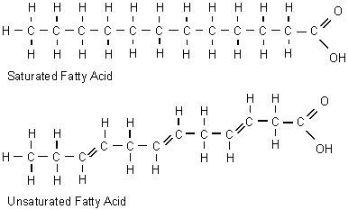

2._____________________

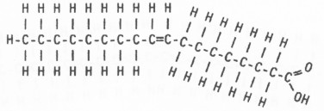

3._____________________

Nucleic Acids
Explain the two types of nucleic acids (DNA, RNA) by their structure, characteristics and functions.

Explain the structure and pairing of the nucleotides of nucleic acids.

Draw and label a picture of a nucleotide.

Explain the relationship between nucleic acids and proteins.

Carbohydrates
What elements make up a carbohydrate? What ratio are these always found in?

Describe a carbohydrate. What is the function of carbohydrates?

What is a disaccharide? Draw the reaction of two glucose molecules that combine to form maltose (draw the structures)

What are polysaccharides? Describe the structure and function of starch, cellulose, and glycogen.

Study the diagrams below, which show carbohydrate molecules. Beside each molecule, write whether it is a monosaccharide, a disaccharide, or a polysaccharide.

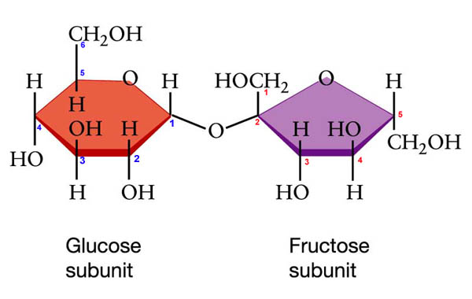
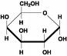
1._______________________ 2._________________________

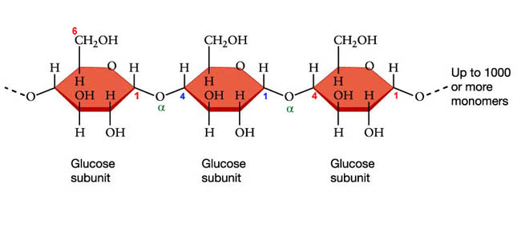
3.________________________________

4. What is the function of #1 in our bodies?
5. What is the function of #3 in our bodies?

6. What is the name of the chemical process that joined the disaccharide and the polysaccharide?

Part A. Classify each as a carbohydrate, protein, lipid or nucleic acid(only used once).
1. | Starch | 9. | Polysaccharide
2. | Cholesterol | 10.__________________ | Phospholipid
3. | Steroid | 11. | DNA & RNA
4. | Glycogen | 12. | Monosaccharide
5. | enzyme | 13. | Cellulose
6. | saturated fat | 14. | amino acid
7. | polypeptide chain | 15. | unsaturated fatty acid
8. | Glucose

Part B. Identify the specific molecule (use the above terms) for each description. Some terms may be used more than once. Nucleic acid is used only once.

16. provides long-term energy storage for animals
17. provides immediate energy
18. ______________________________sex hormones
19. stores hereditary information
20. animal and plant structures
21. forms the cell membrane of all cells
22. speeds up chemical reactions by lowering activation energy
23. one sugar
24. monomer of proteins
25. provides long-term energy storage for plants
26. steroid that makes up part of the cell membranes
27. ______________________________ soluble only in hydrophobic solvents
28. provides short-term energy storage for animals
29. many sugars
30. forms the cell wall of plant cells
Part C. Which specific molecule (saturated fat, unsaturated fat, protein, glucose, starch, cellulose) is each food mostly made of?

31. | butter | 39. | celery
32. | spinach | 40. | cream
33. | beef jerky | 41. | cranberries
34. | bacon | 42. | egg white
35. | noodles | 43. | table sugar
36. | orange juice | 44. | popcorn
37. | cheese | 45. | lobster
38. | wheat | 46. | sesame oil

Part D. State whether each is found in animals, plants or both.
47. | saturated fat | 53. | glucose
48. | protein | 54. | enzyme
49. | steroid | 55. | polysaccharide
50. | amino acid | 56. | glycogen
51. | monosaccharide | 57. | starch
52. | cellulose | 58. | phospholipid
Part E. Which food molecule (monosaccharide, polysaccharide, lipid, protein) would you eat if…
68. …you needed a quick boost of energy?
69. …you wanted to grow strong nails?
70. …you haven’t eaten in days?
71. …you wanted to grow healthy hair?
72. …you had a race tomorrow afternoon?
73. …you were getting ready for hibernation?
74. …you wanted to get bigger muscles?
75. …your next meal will be in a week?

