Muscles Review Worksheet. Name:______________________

Mr. McKenzie Hr. ______

Biology B

Label the muscles in each area of the body.

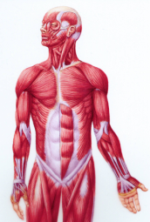

1.

8.

2.

3. 9.

4. 10.

5.

6.

7.

11.

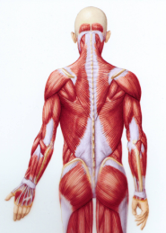

16.

12.

17.

13.

14. 18.

15.

19. Name the muscles of the rotator cuff ___________________ ____________________

____________________ ____________________

20. Name the Muscles of the Quadriceps. _____________________ ________________________

______________________ ________________________

21. Name the Muscles of the Ham Strings. _______________ _________________ ______________

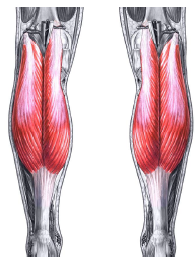

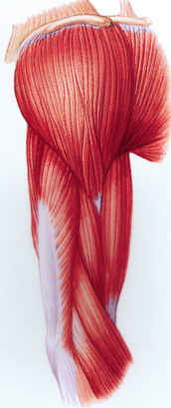

24.

25.

26.

27.