Earth Science Learning Targets
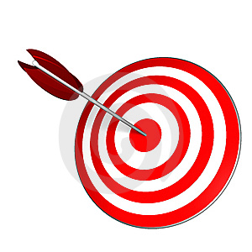
Unit: Matter and Measurement

The following is a list of the things you will know and be able to do when you are finished with the Matter and Measurement Unit.

* = M&M (MUST Master at 80%)
 | Learning Target | Essential Vocabulary | Formative Quiz Score | What did you do After Quiz?
0 | I can set up a scientific investigation and analyze the data collected to draw conclusions.
*1 | I can use a triple beam balance, graduated cylinder, and a ruler to collect data. | Pretest Scores:  Length:  Liquid Volume:  Mass:  Solid Volume:  Temp.:  Converting:
*2 | I can make a data table and a line graph.
3 | I can find the density of an object using its mass and volume. | - Mass  - Volume  - Density  - Displacement Method
*4 | I can explain a physical change and use evidence to identify a physical change. | - Physical change  - Physical property  - Phase  - Conservation of mass  - Dissolving  - Melting point  - Boiling point  - Freezing point  - Open System  - Closed System
*5 | I can explain a chemical change and use evidence to identify a chemical change. | - Chemical change  - Chemical property  - Chemical reaction  - Chemical equation  - Reactant  - Product
6 | I can explain the difference between pure substances and mixtures using physical properties. | - Solubility  - Pure substances  - Mixture
*7 | I can explain the differences between elements and compounds in terms of atoms and molecules. | - Atoms  - Compounds  - Molecules  - Elements  - Periodic Table of Elements
8 | I can distinguish between acids and bases, and between metals and non-metals. | - Acids  - Bases  - Metals  - Non-metals  - Conductivity  - Insulator  - Conductor

