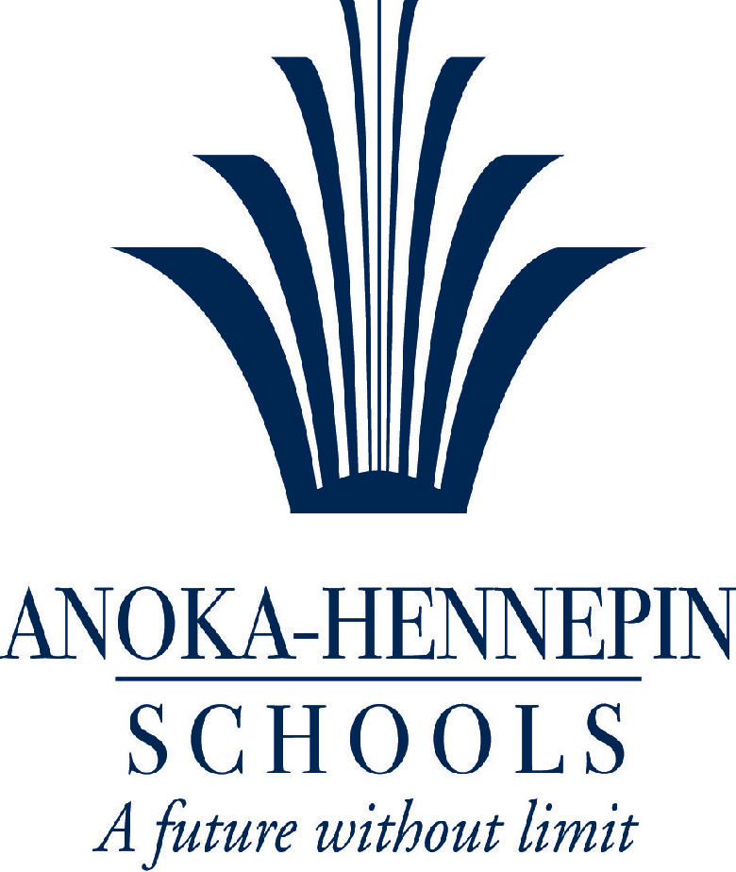

Anoka-Hennepin Education Technology Plan

July, 2018

Executive Summary

Since the implementation of our last technology plan, Anoka-Hennepin has seen significant changes in closing the digital divide. We have increased our access to digital devices nearly 300%. We have moved away from fixed computer labs with scarce availability, to carts of mobile devices and quantities that approach one device per student.

Despite the significant rise in mobile devices, a different type of divide persists. Anoka-Hennepin is not alone in this phenomenon as the National Education Technology Plan of 2017 (NETP) states:

* Few schools have adopted approaches for using technology to **support informal learning experiences aligned with formal learning goals.**
* Assessment approaches have evolved but still do not use technology to its full potential to measure a broader range of desired educational outcomes, **especially non-cognitive competencies.**
* The **focus on providing Internet access and devices for learners should not overshadow** the importance of preparing teachers to teach effectively with technology and to select engaging and relevant digital learning content.
* As students use technology to support their learning, schools are faced with a growing need to **protect student privacy** continuously while allowing the appropriate use of data to personalize learning, advance research, and visualize student progress for families and teachers.
* While school and district leaders often leverage data for decision-making, many still **need support and better tools** so they can get real-time information on how strategies are working through rigorous, quick-turnaround evaluations of technology.
* Many schools do not yet have access to or are not yet using technology in ways that can improve learning on a daily basis, which underscores the need—guided by new research—to **accelerate and scale up adoption of effective approaches** and technologies.
* A **digital use divide** continues to exist between learners who are using technology in active, creative ways to support their learning and those who predominantly use technology for passive content consumption.

As we approach nearly 3 decades of effort trying to leverage technology to improve schools, we have integrated these tools to make improvements to what we already do; instead of asking how they should fundamentally determine what students should know and how they may go about learning in powerful ways. What we do naturally, is measure our goals by counting devices or applications instead of examining how the student experience can be redesigned or changed. That is the shift proposed in this plan; to focus on new experiences for students, to find ways to qualify and quantify the differences, and to do so while recognizing the support, leadership and pacing needed to do this work well. **We propose to define and reduce the digital use divide.**

Every Student, a Successful Digital Learner

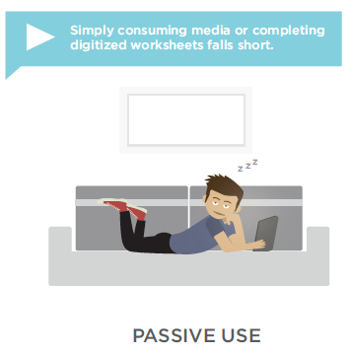

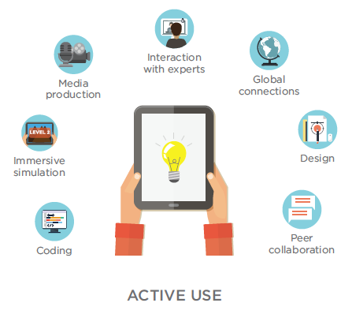

**Goal 1:** Create a future-focused set of skills and embed them in new digital and non-digital experiences.

|  |  |  |  |
| --- | --- | --- | --- |
| **Target Area** | **Why this Matters** | **Year 1** | **Year 3** |
| Future-Focused Skills | Today’s students need a variety of cognitive and personal skills that allow them to adapt to a quickly changing world | Skills identified and reviewed by parents, community, business, educators and school board.  First draft adopted by end of year 1. | Adopted skills are implemented and assessed within the capacity of change for our system.  Anoka-Hennepin has tools to monitor status and progress. |

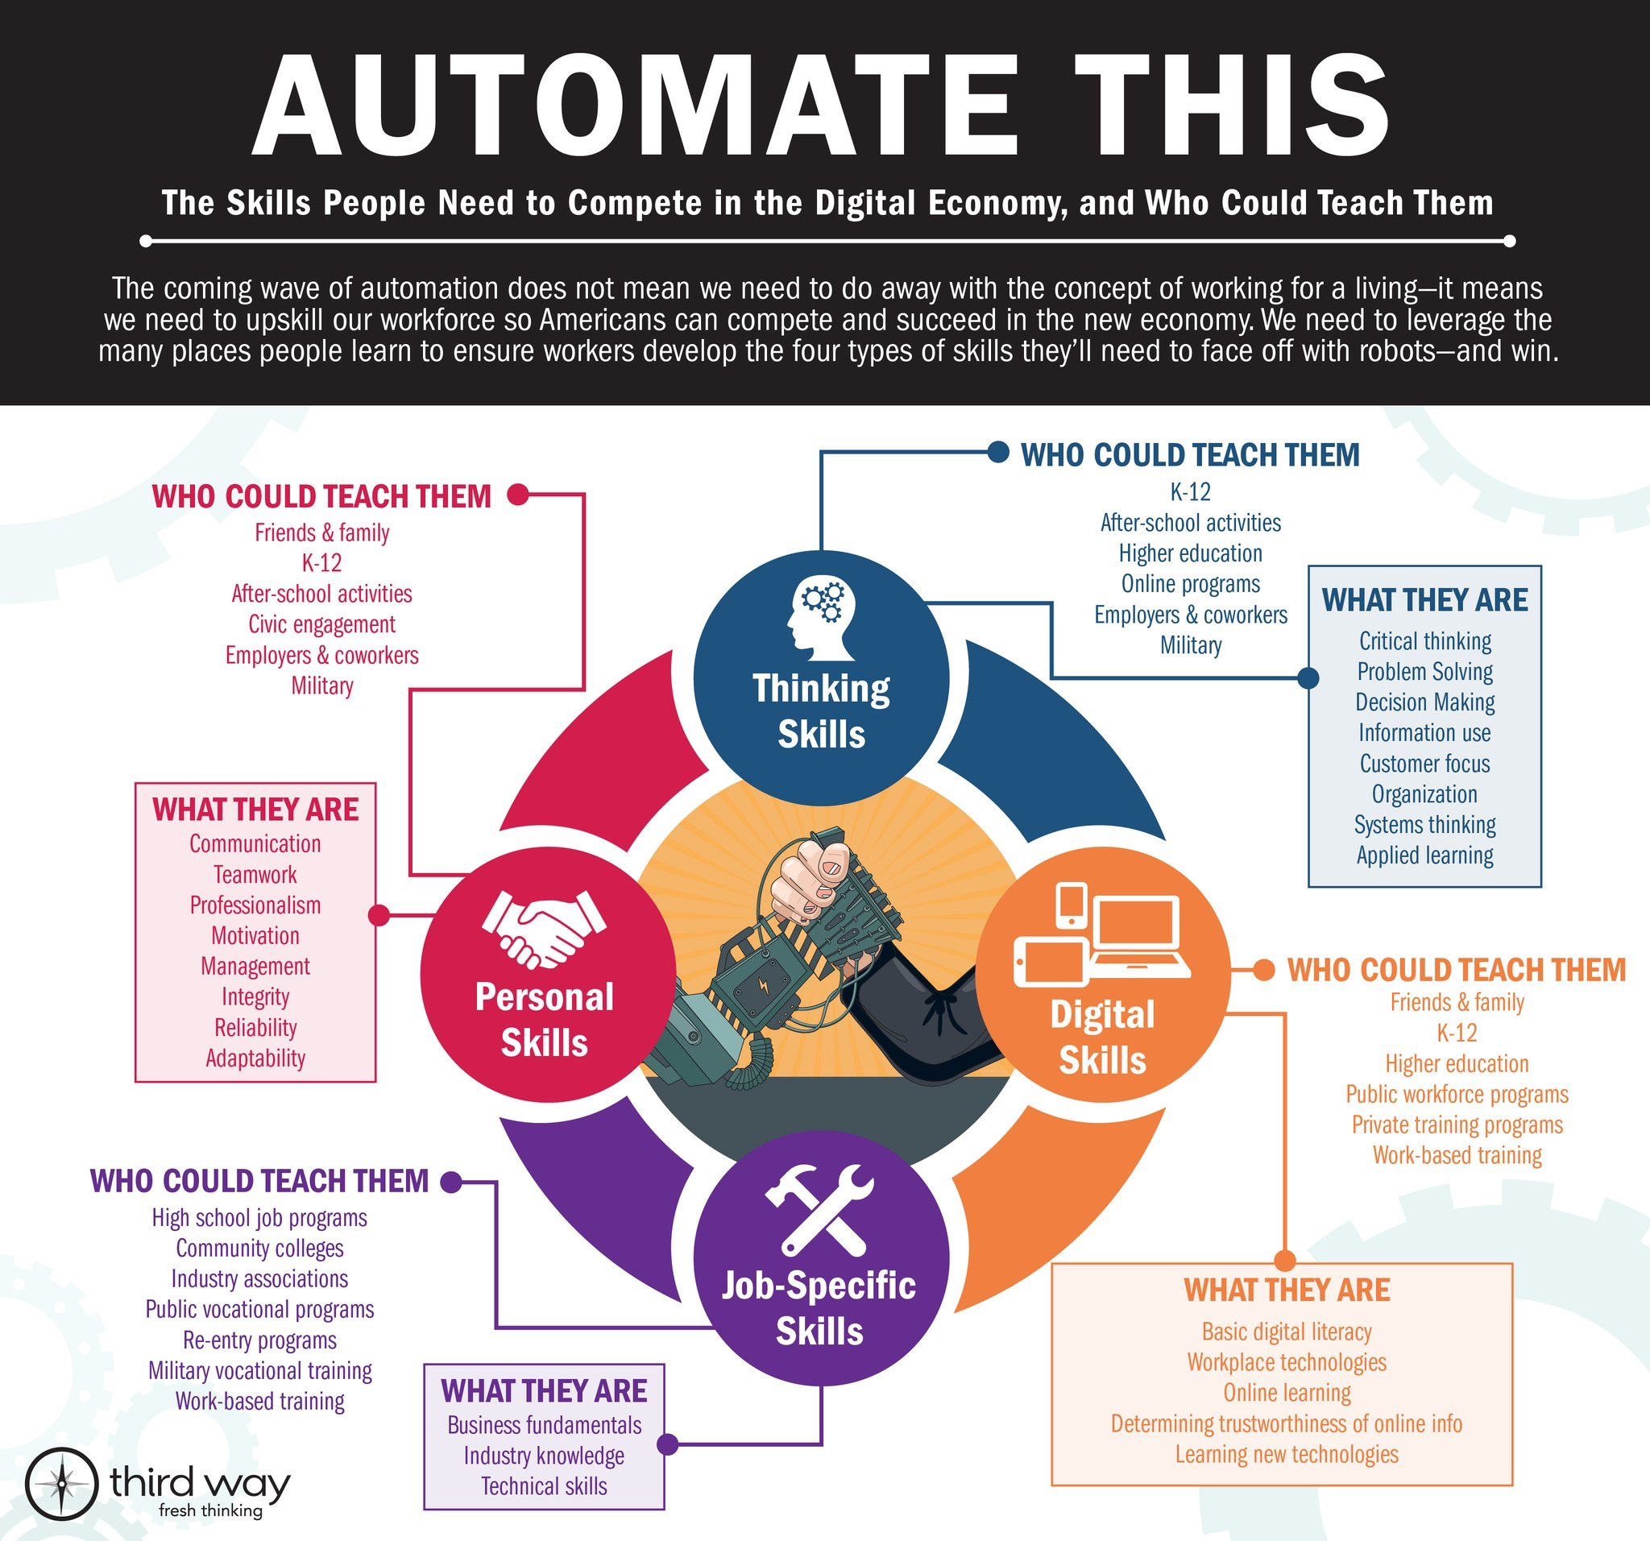

**Goal 2:** At the district’s high schools, deliver a consistent student experience by leveraging a 1:1 environment paired with intensive efforts to **augment**, **modify** or **redesign** learning experiences.

|  |  |  |  |
| --- | --- | --- | --- |
| **Target Area** | **Why this Matters** | **Year 1** | **Year 3** |
| Consistent Experiences / Environment | Our best implementations to-date start with vision, professional development and support to help implement that vision and a means to monitor the progress | Determine from options and models for consistent environments  A School Board approved plan is in place in the February timeframe | The model is 75% to 100% implemented in high schools  Common experiences are defined and assessed  Parental / Educator / Student Feedback shows high degrees of satisfaction |

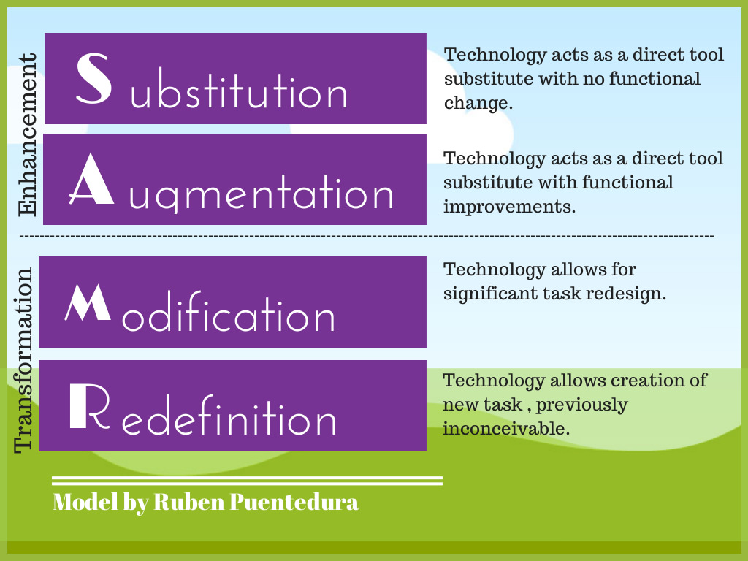

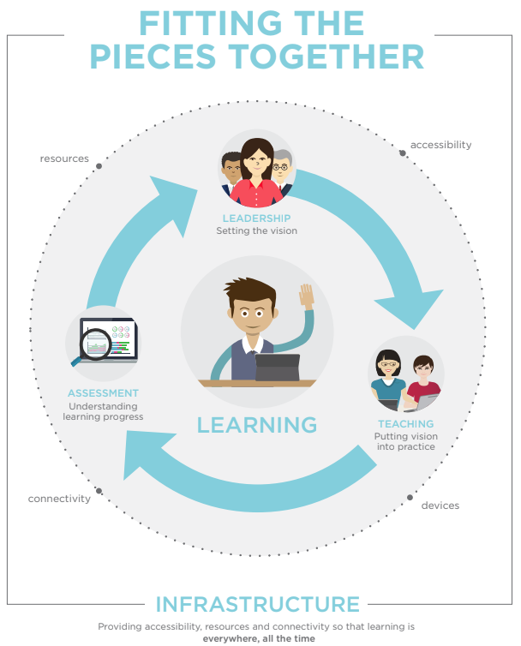

**Goal 3:** Continue efforts to build capacity in educators in various roles at the district office and school-level.

|  |  |  |  |
| --- | --- | --- | --- |
| **Target Area** | **Why this Matters** | **Year 1** | **Year 3** |
| Capacity Building | Leaders at all levels as well as educators will need to engage in any body of work that is designed to be transformative. | Completion of a redesigned plan for district and site-based leadership  Completion of a plan to address skills gaps within teachers | Evaluations of each of these programs show measurable progress and high degrees of satisfaction among members |

**Goal 4:** Explore ways to improve decision-making through data systems while at the same time, strengthening efforts aimed at data privacy.

|  |  |  |  |
| --- | --- | --- | --- |
| **Target Area** | **Why this Matters** | **Year 1** | **Year 3** |
| Data for Decisions | We currently utilize a variety of tools for visualizing student-related data. As we continue to refine processes such as Multi-Tiered Systems of Support, we may need systems to better align with these goals. | Complete a systems-review of current offerings and conduct a gap analysis with relevant stakeholders. | Any newly recommended systems should be implemented and assessed within the end of year 3. |

|  |  |  |  |
| --- | --- | --- | --- |
| **Target Area** | **Why this Matters** | **Year 1** | **Year 3** |
| Data Privacy | As technology continues to evolve and cloud-based applications grow, we have a responsibility to place data privacy in a cycle of continuous improvement. | Conduct a systems and practices review with recommendations for changes to be decided before the end of this school year. | Any new practices should be in place and assessed in year 3 with recommendations for improvement. |